**Which salesperson sold the lowest amount in January?**

1. Select all your data in the table.
2. Click on Insert 🡪 Pivot Table. You will then see this screen.

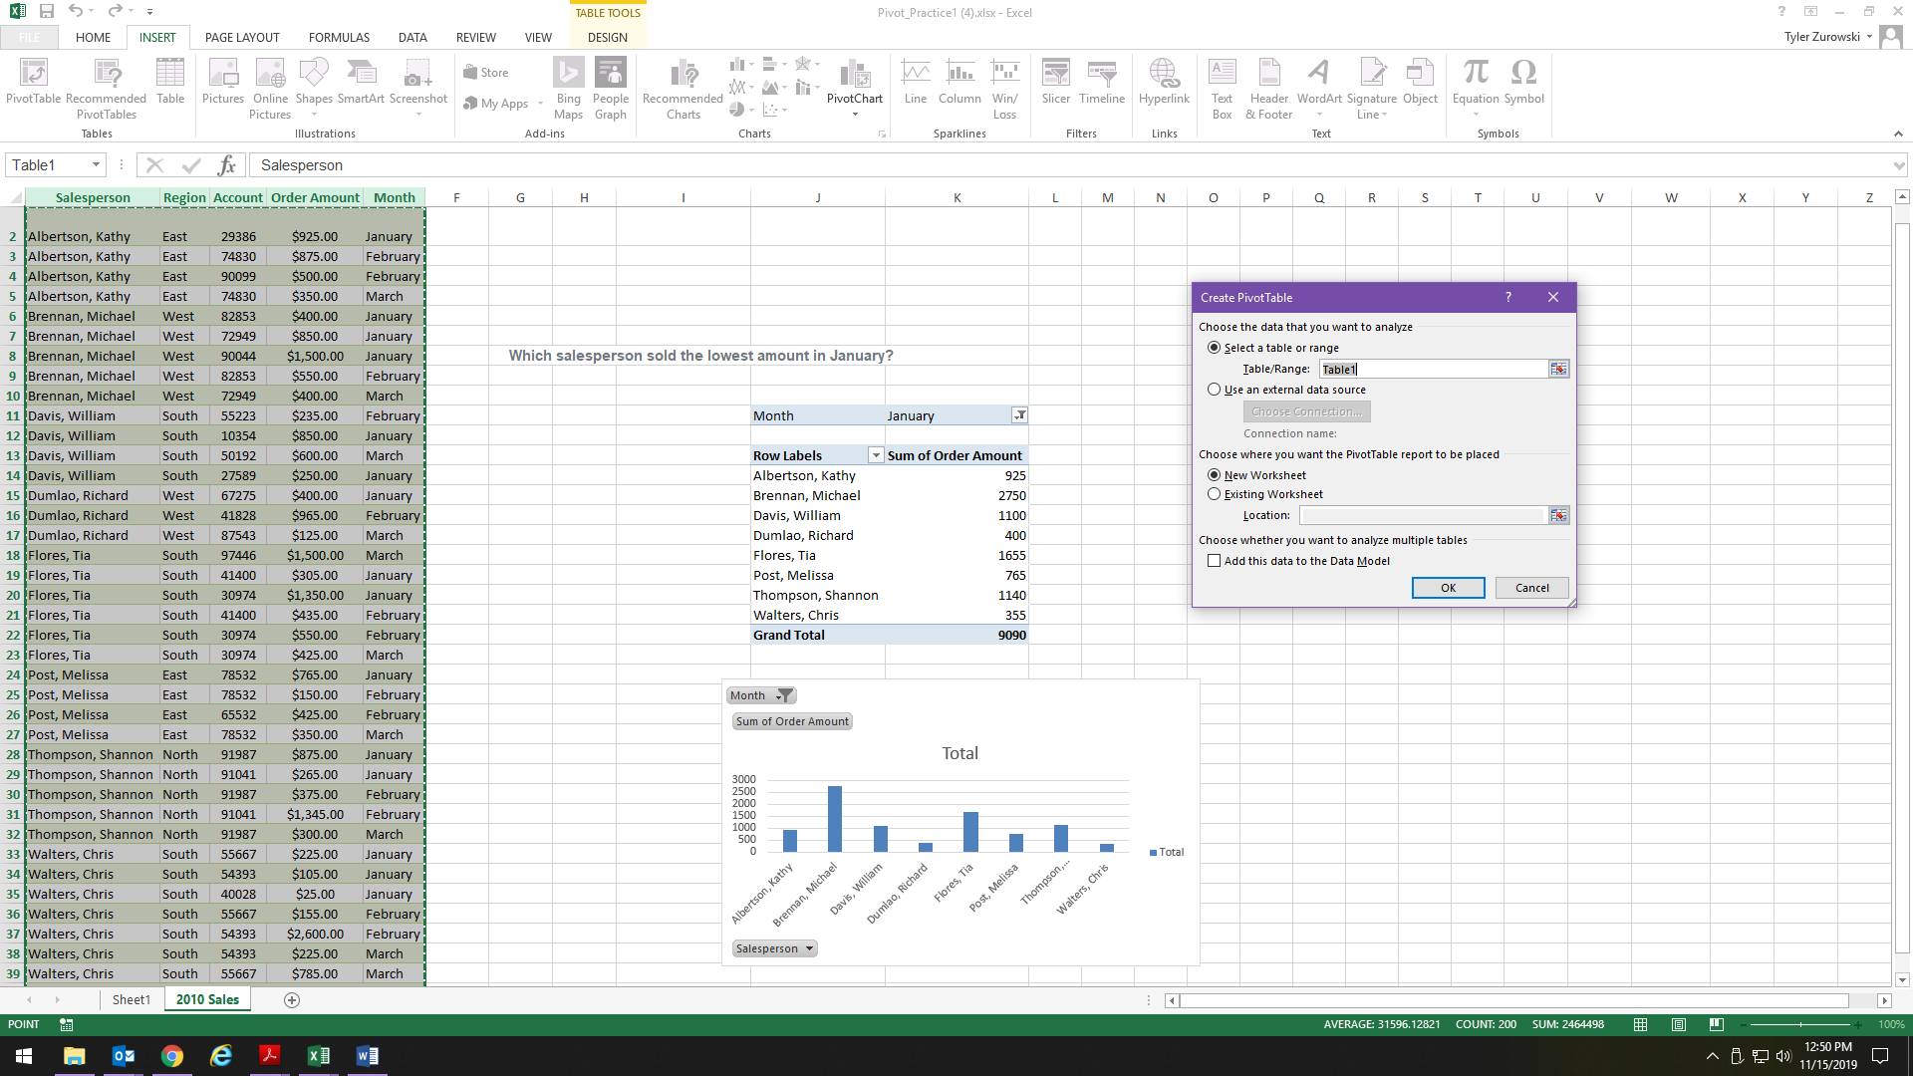

You can either choose “New Worksheet” or click on “Existing Worksheet”. If you click on Existing Worksheet, then you must click on an empty cell on your worksheet where you want the Pivot Table to be placed.

1. On the right side, select Salesperson, Order Amount, and Month.
2. Then on the right side, click on Month and drag it into the Filter area. You should then see a screen like this …

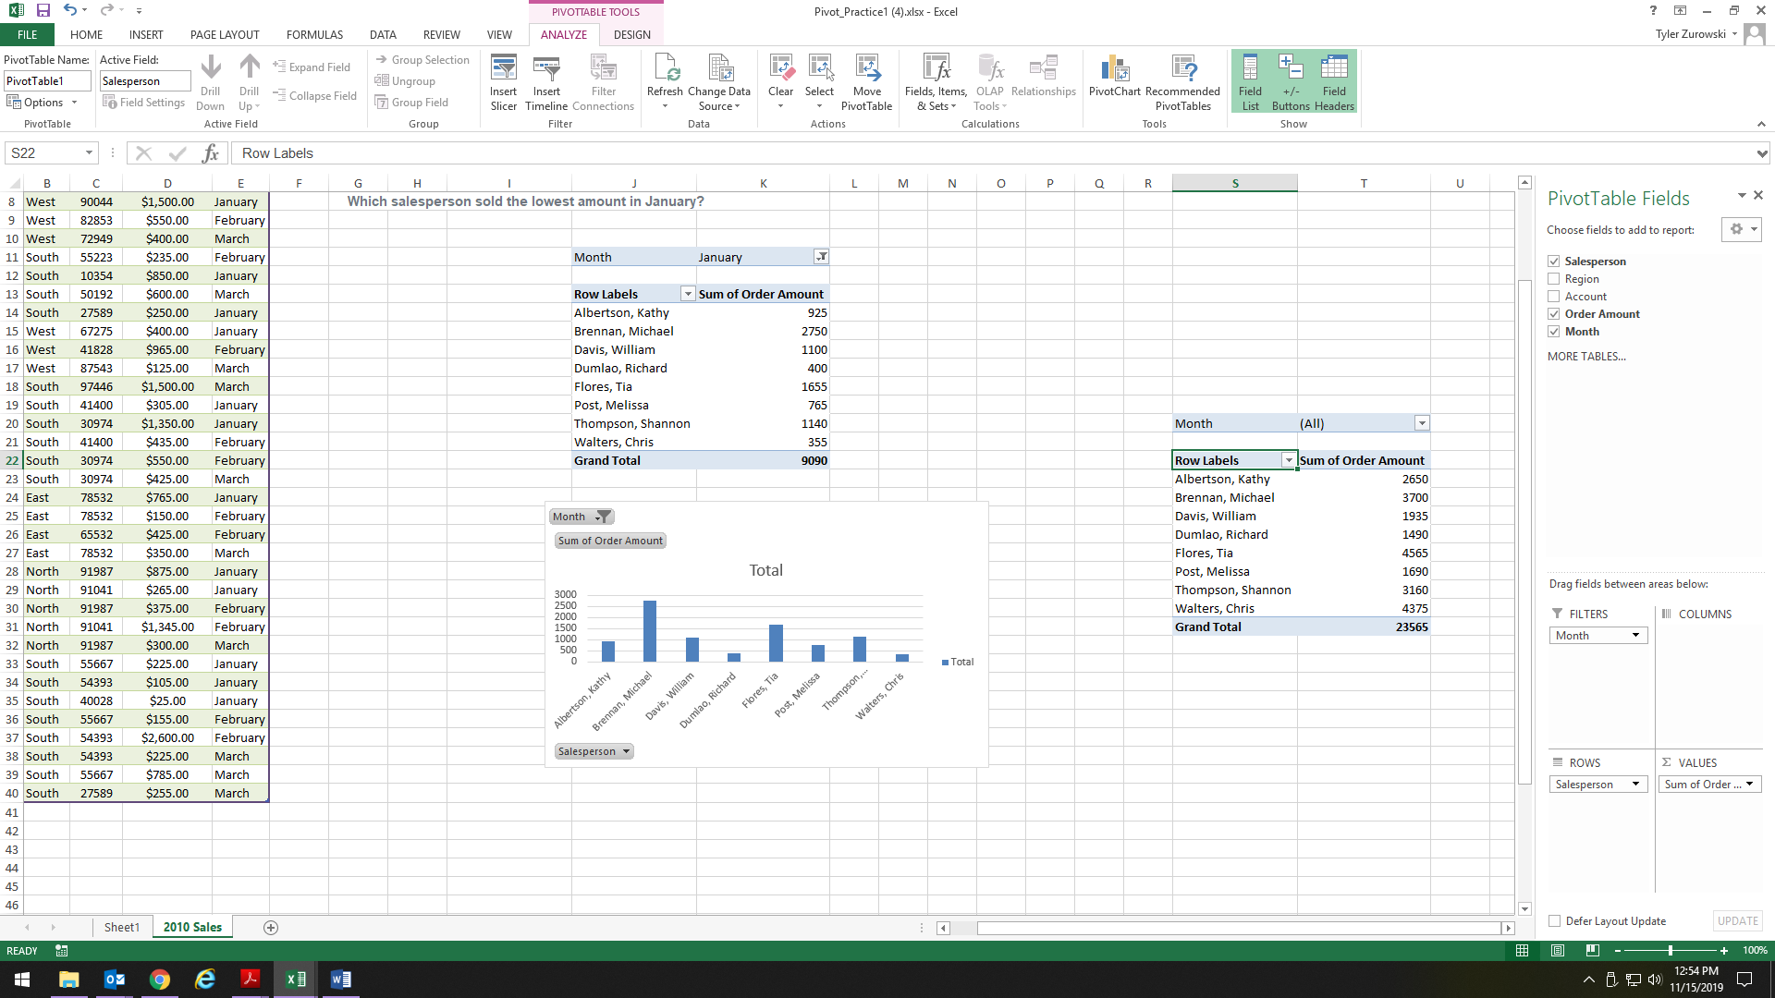

1. Now you need to click on the arrow next to Month in order to filter out all of the months except for February.